NON-PROFIT JOINT-STOCK COMPANY
«KARAGANDA UNIVERSITY
NAMED AFTER ACADEMICIAN E.A.BUKETOV»

APPENDIX TO THE REPORT
ON THE RESULTS OF SELF-ASSESSMENT
EDUCATIONAL PROGRAM
WITHIN THE FRAMEWORK OF SPECIALIZED ACCREDITATION
"8D01102 - PSYCHOLOGY OF EDUCATION"

Karaganda, 2022
CONTENTS

Annex A1. A copy of the license for the right to conduct educational activities 4
Annex A2. Certificate of Institutional Accreditation 7
Annex A3. Organizational structure of Karaganda University named after academician E.A. Buketov 8
Annex A4. Quality policy of Karaganda University named after academician E.A. Buketov 9
Appendix B1. Modular educational program "8D01102-Psychology of Education" 10
Appendix B2. academic calendar 23
Appendix B3. Curriculum 24
Annex B4. Catalog of elective disciplines 26
Appendix B5. Sample of Syllabus 30
Appendix C1. Contingent of doctorants 40
Table 2. Contingent of students by semesters 41
Table 3. Graduates 41
Appendix D2. Human resources of the EP 42
Table 1. Basic information about faculty members within EP 42
Table 2 Research work of the faculty members on EP 43
Table 3 Teachers of major subjects (MS) by language proficiency 52
Table 4. Information on professional development (advanced training) of faculty members 53
Table 5. Publication activity of teaching staff 54
Table 6. Partnership with enterprises 55
Table 7. Partnership with schools, organizations of technical and vocational education and 55
organisations of higher and postgraduate education 55
P.1. Evaluation sheets for attended classes 57
Appendix D3. Material and technical resources of the EP and student support system 59
Table 1 Availability of information and communication equipment 59
Table 2 Type of Internet connection 59
Table.3 Maximum data transmission over the Internet 59
Table 4 Availability of special software 59
Table.5 Availability of the website 59
Table 6 Availability of information on the activities of the organisation of higher and postgraduate education on the website 60
Table 7. Purchasing new books 60
Table 8 Access to information technology resources 60
Table9 Library resources 61
Table 10. Student dormitories 62
Table 11. Canteens 62
Table 11. Sports and cultural infrastructure 62
Table 13. Medical center 63
Table 14. Receipt of fixed assets to the Faculty of Philosophy and Psychology 63
Annex E. Survey results 64
P.1. Questionnaire "Satisfaction of doctoral students with the quality of the implementation of the educational program" 8D01102 - Educational Psychology" 64
P.2. Questionnaire "Satisfaction of doctoral students with the work of domestic and foreign scientific consultants" 65
P.3. Questionnaire "Satisfaction with the studied discipline" 66
P.4. Questionnaire "Satisfaction of employers with the quality of graduate training" 66
Appendix F. EP Development Plan 67

Annex A1. A copy of the license for the right to conduct educational activities

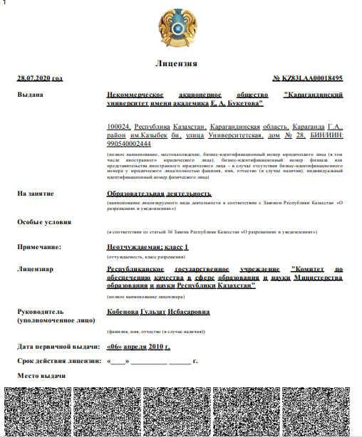

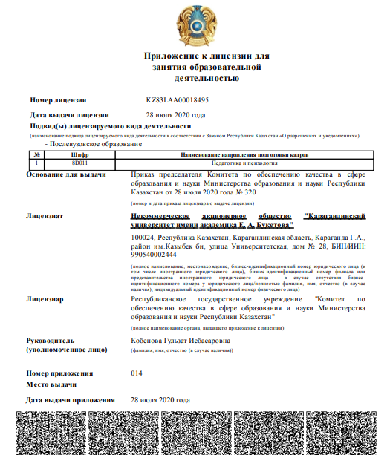

Annex A2. Certificate of Institutional Accreditation

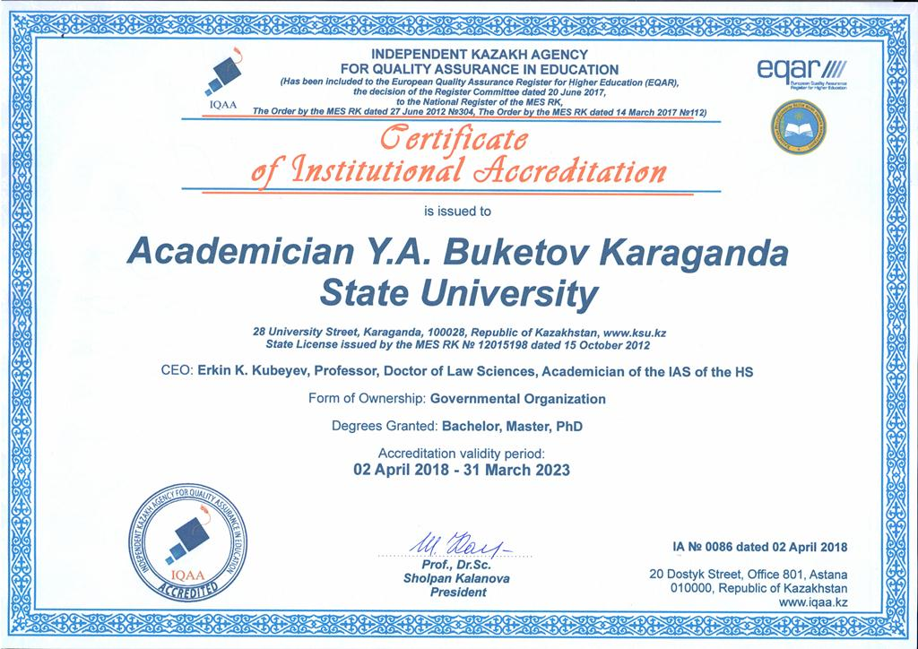

Annex A3. Organizational structure of Karaganda University named after academician E.A. Buketov
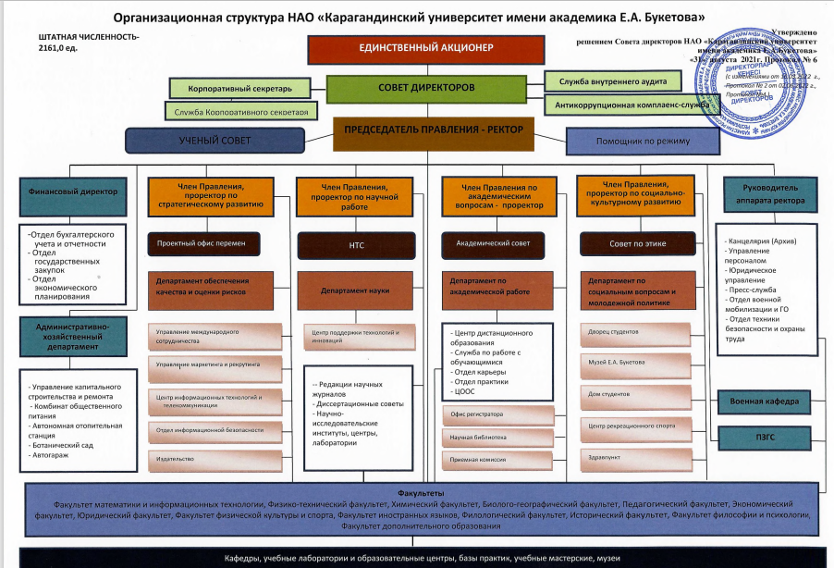

Annex A4. Quality policy of Karaganda University named after academician E.A. Buketov

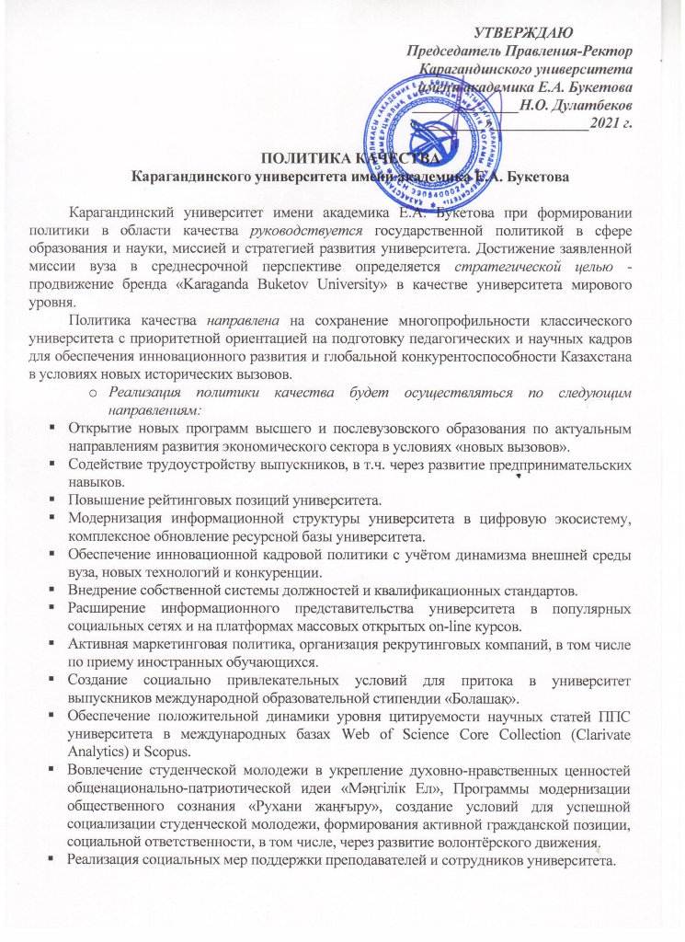

Appendix B1. Modular educational program "8D01102-Psychology of Education"

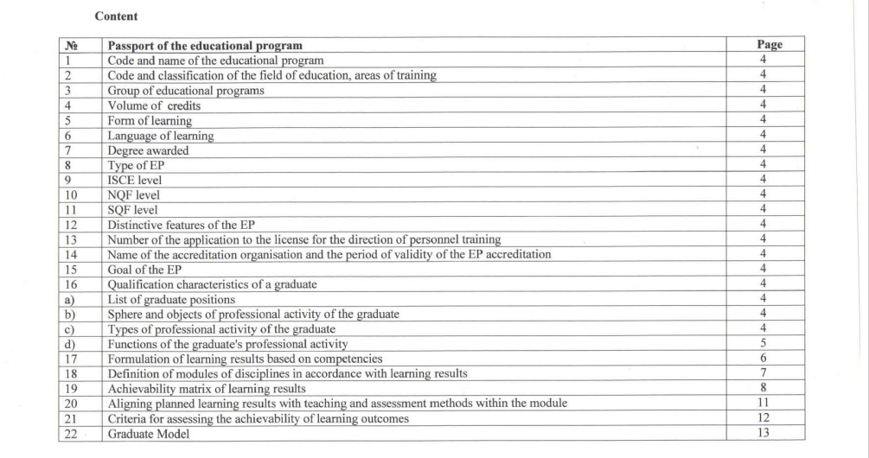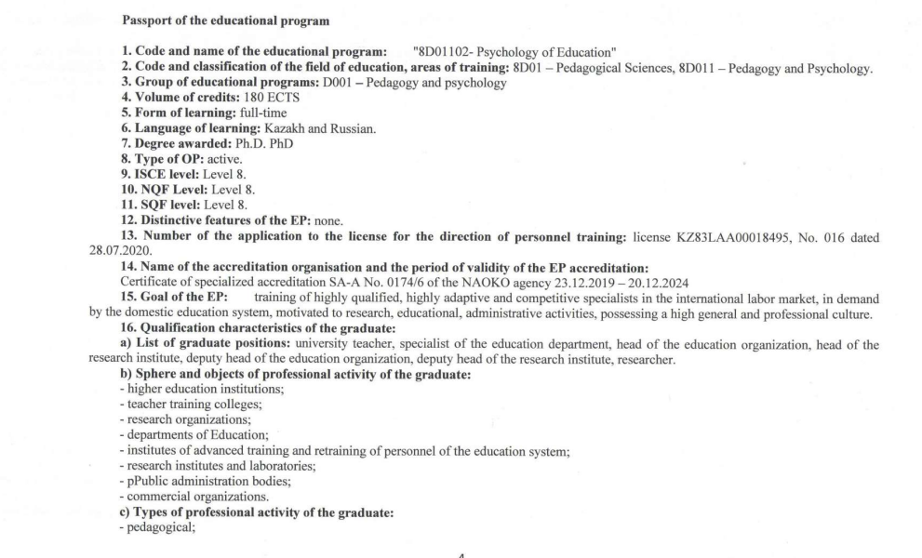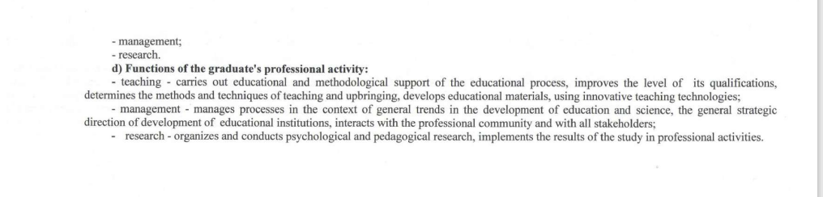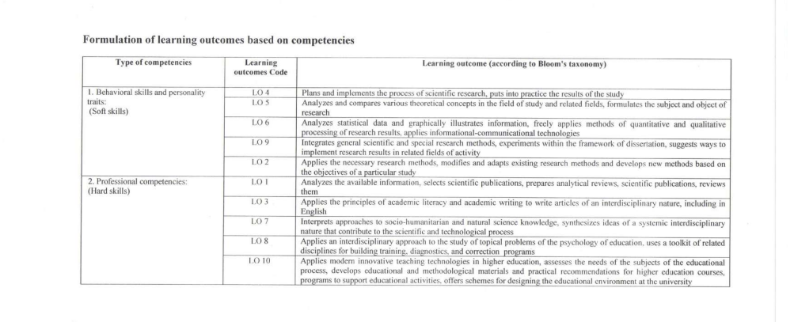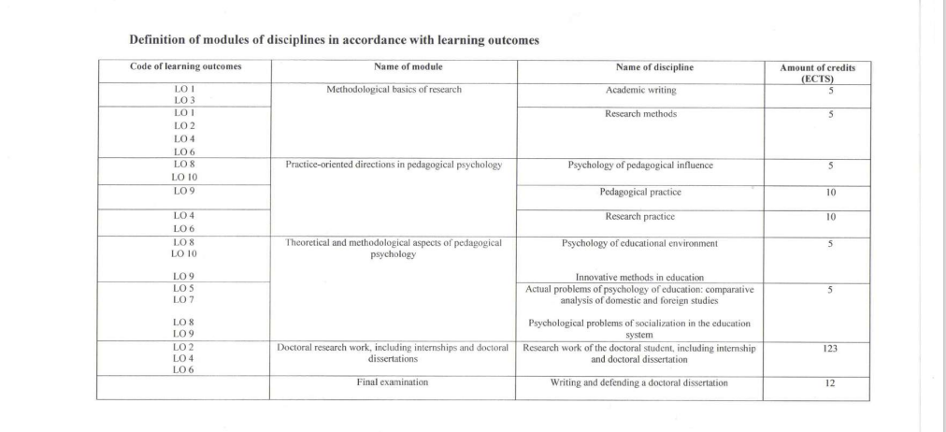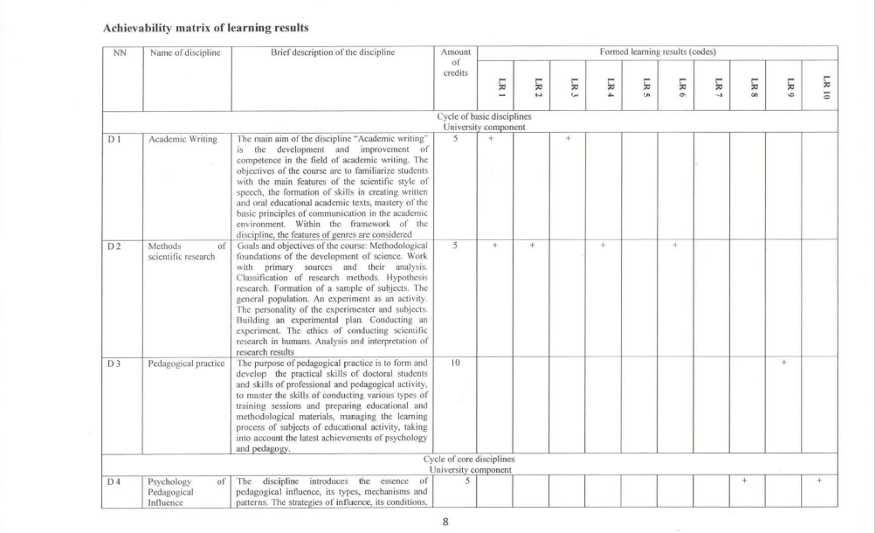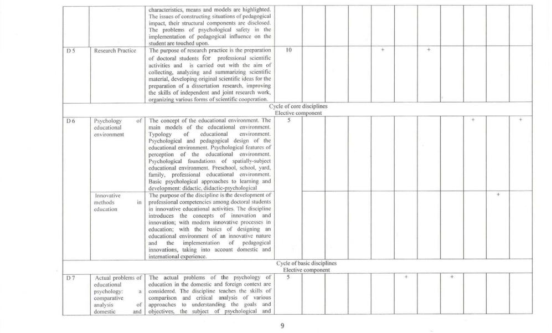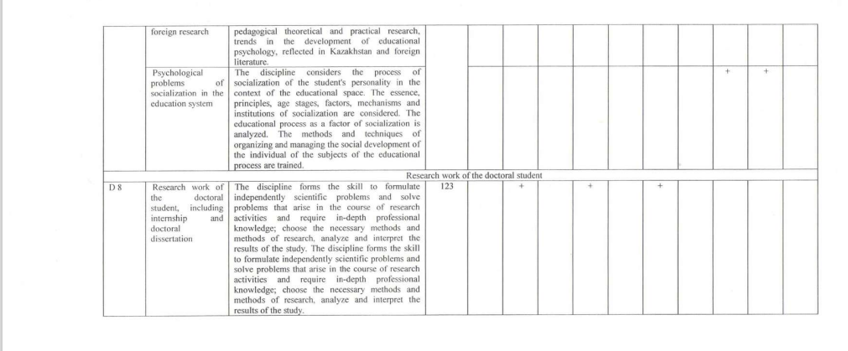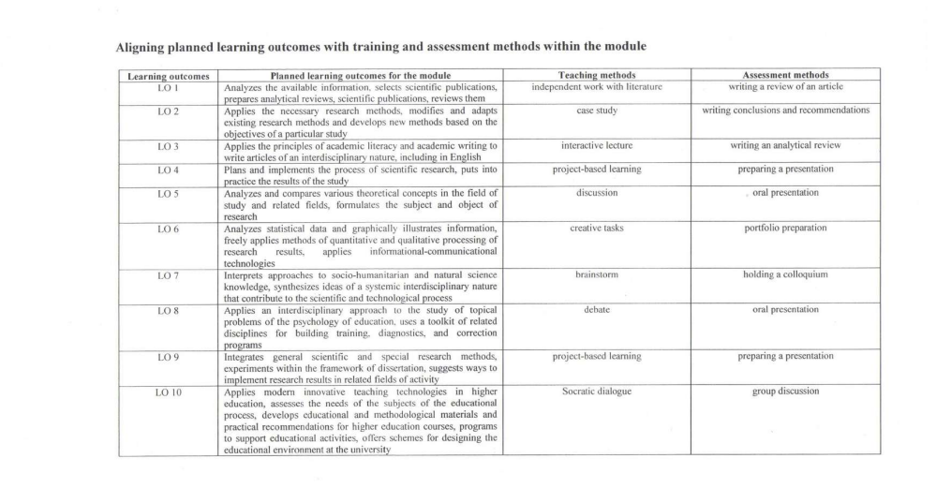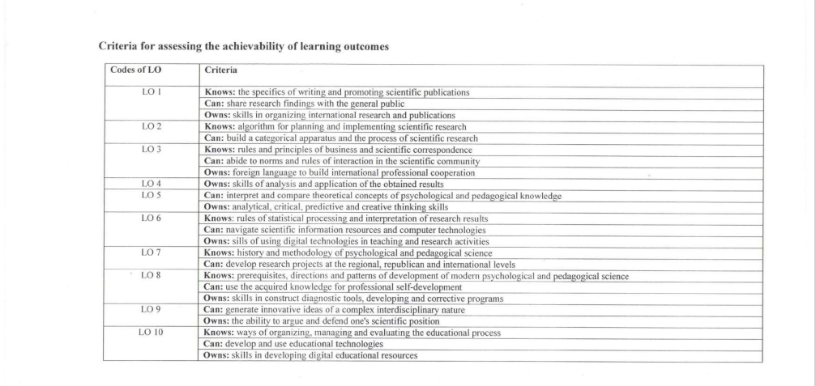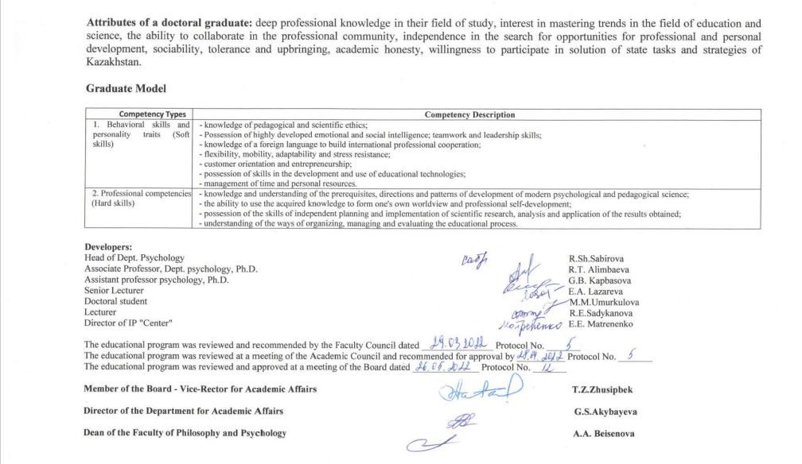

Appendix B2. academic calendar

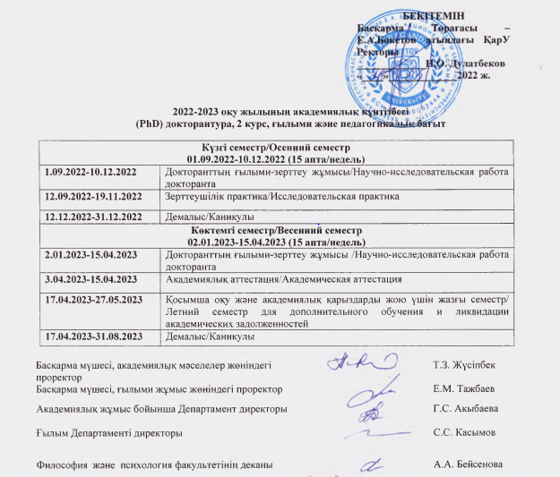

Appendix B3. Curriculum

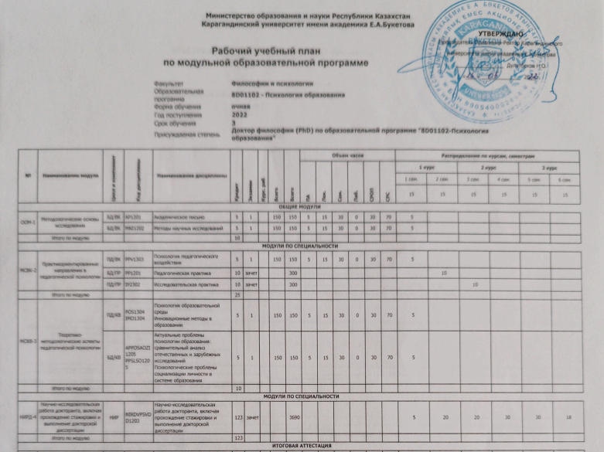
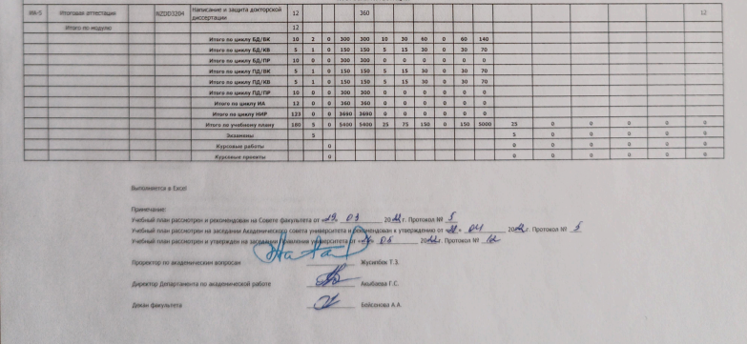

Annex B4. Catalog of elective disciplines

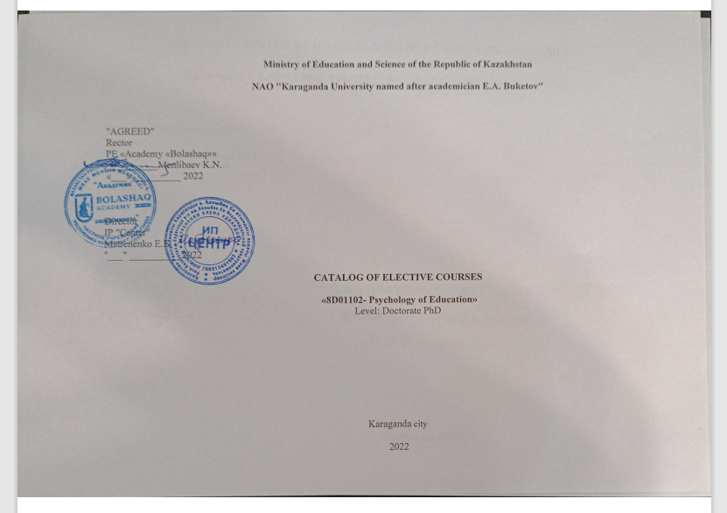
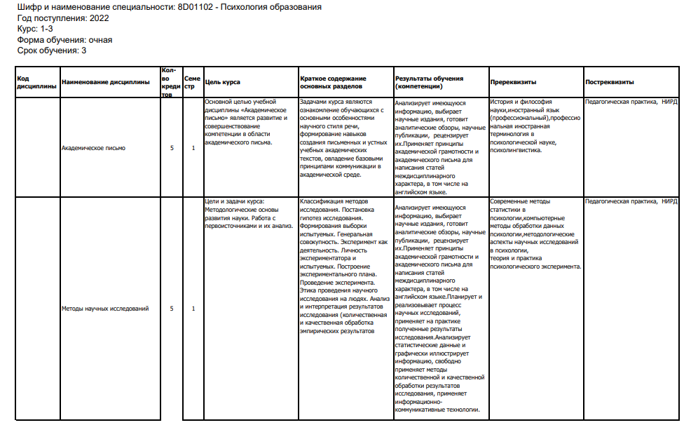

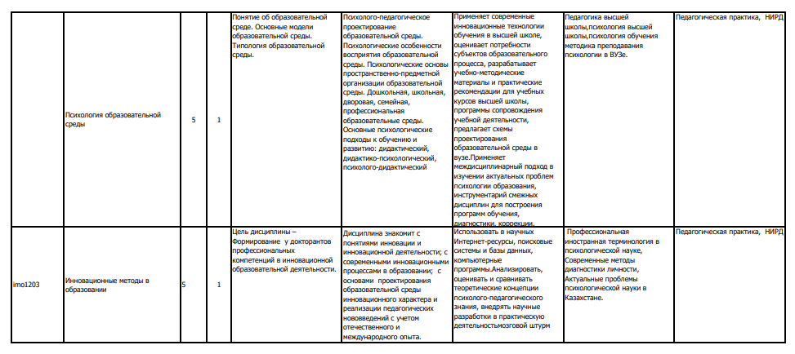

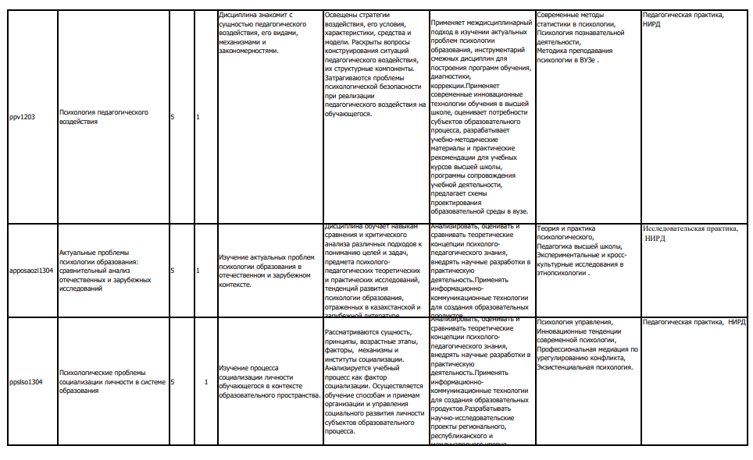

Appendix B5. Sample of Syllabus
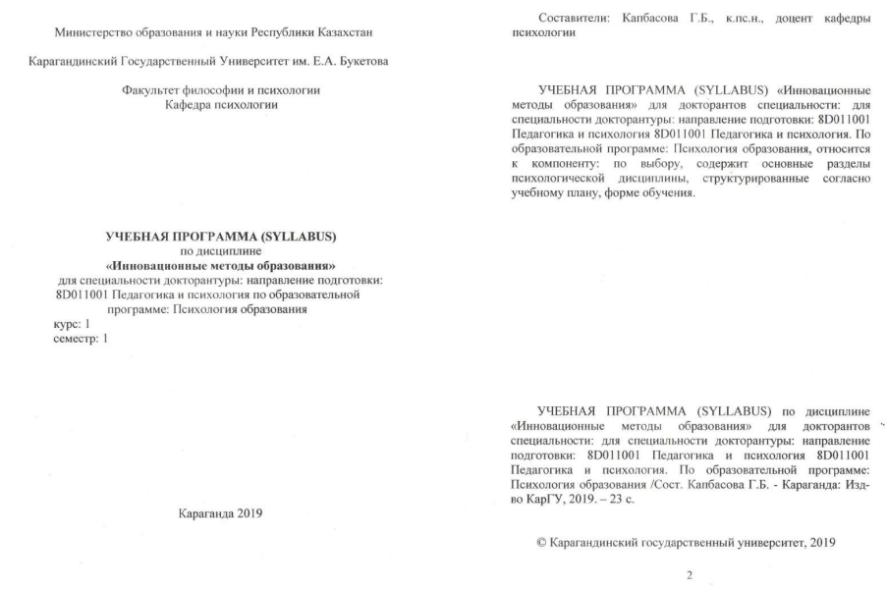
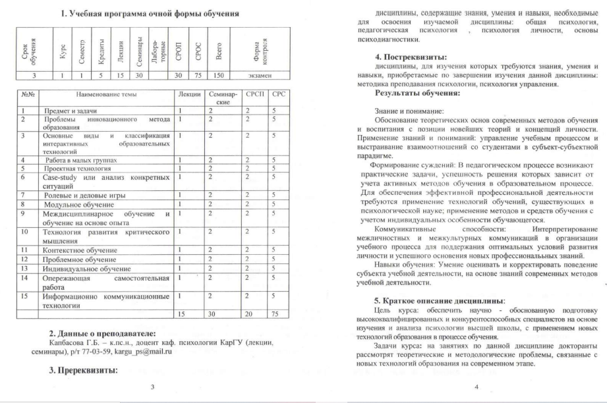
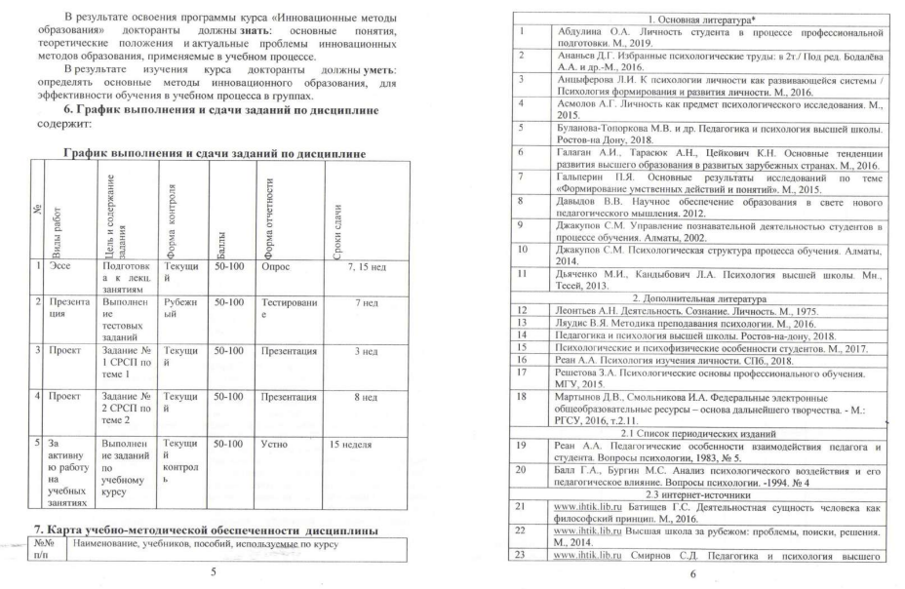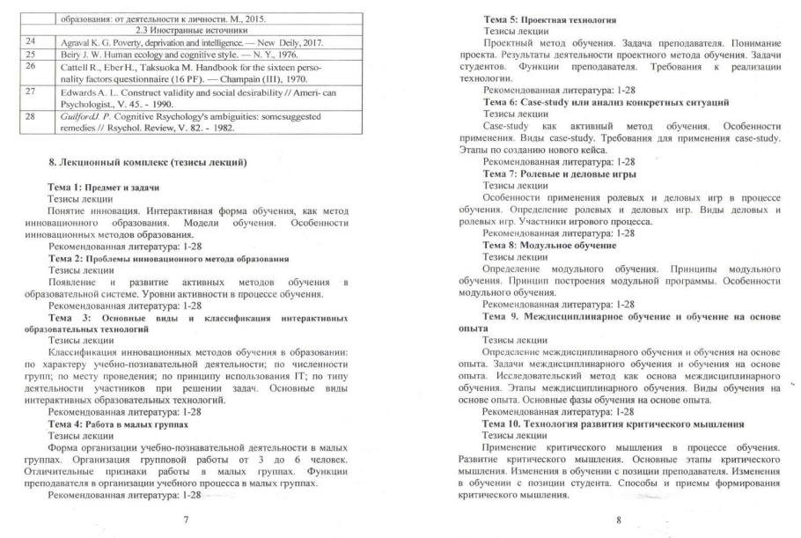
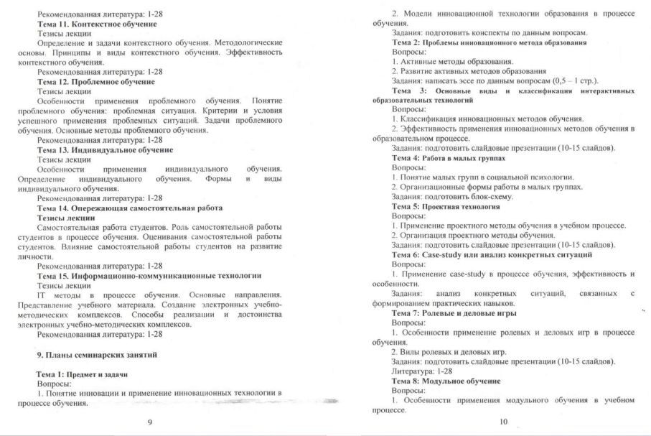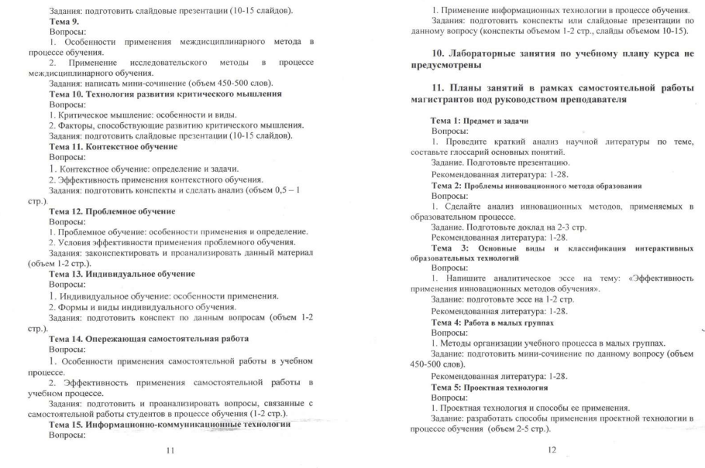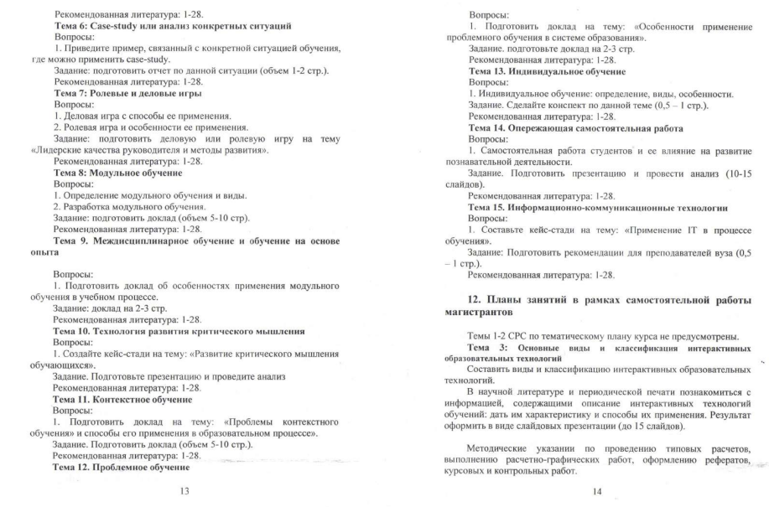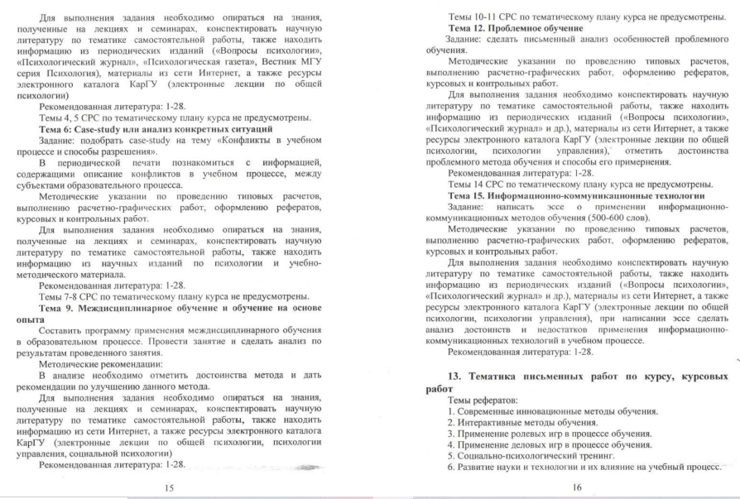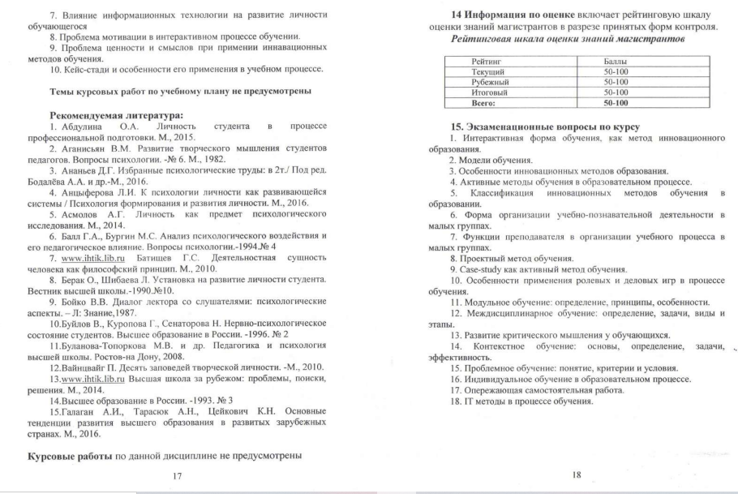
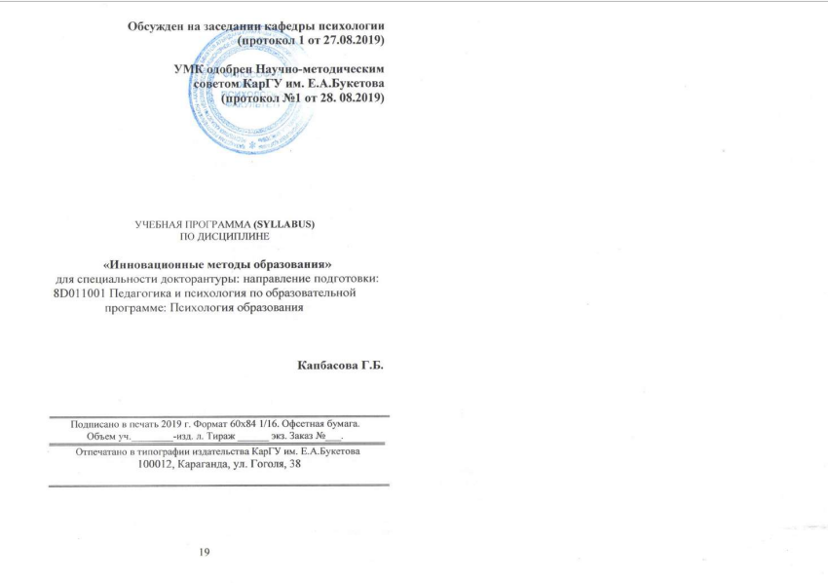

Appendix C1. Contingent of doctorants

Table 1. Total number of EP students

Academic year | Form of education |  | Number of students by year |  |  | Number of students transferred from other universities | Number of students expelled | otal for all years of study
 |  |  | I | II | III
2019/2020 | Full time | educational grant | 2 | - | - | - | - | 2
 |  | on a fee basis | - | - | - | - | - | -
 | Part-time |  | - | - | - | - | - | -
 | Evening |  | - | - | - | - | - | -
 | External |  | - | - | - | - | - | -
 | DLT |  | - | - | - | - | - | -
2020/2021 | Full time | educational grant | - | 2 | - | - | - | 2
 |  | on a fee basis | - | - | - | - | - | -
 | Part-time |  | - | - | - | - | - | -
 | Evening |  | - | - | - | - | - | -
 | External |  | - | - | - | - | - | -
 | DLT |  | - | - | - | - | - | -
2021/2022 | Full time | educational grant | 2 | - | 2 | - | - | 4
 |  | on a fee basis | - | - | - | - | - | -
 | Part-time |  | - | - | - | - | - | -
 | Evening |  | - | - | - | - | - | -
 | External |  | - | - | - | - | - | -
 | DLT |  | - | - | - | - | - | -
2022/2023 | Full time | educational grant | - | 2 | - | - | - | 2
 |  | on a fee basis | - | - | - | - | - | -
 | Part-time |  | - | - | - | - | - | -
 | Evening |  | - | - | - | - | - | -
 | External |  | - | - | - | - | - | -
 | DLT |  | - | - | - | - | - | -

Table 2. Contingent of students by semesters

№ | Academic year | Number of students per semester
 |  | 1 | 2 | 3 | 4 | 5 | 6 | 7 | 8 | 9 | 10 | Total
1 | 2019/2020 | 2 | 2 | 2 | 2 | 2 | 2 | 2 | 2 | 2 | 2 | 2
2 | 2020/2021 | 2 | 2 | 2 | 2 | 2 | 2 | 2 | 2 | 2 | 2 | 2
3 | 2021/2022 | 4 | 4 | 4 | 4 | 4 | 4 | 4 | 4 | 4 | 4 | 4
4 | 2022/2023 | 2 | 2 | 2 | 2 | 2 | 2 | 2 | 2 | 2 | 2 | 2

Table 3. Graduates

№ | Academic year | Number of graduates | Were employed in the first year of graduation
1 | 2021/2022 | 2 | 2

Appendix D2. Human resources of the EP

Table 1. Basic information about faculty members within EP

 |  | Regular staff | Part-time | Total number
Type of employment | 1,0 | 6 |  | 6
 | 0,5
 | 0,25
Average age |  | 57,8
Degree | Master of Science
 | Candidate of Sciences | 4
 | Doctor of Science | 1
 | PhD | 1
Academic rank | Professor's Assistant | 1
 | Associate professor | 3
 | Professor | 2
 | Academician | 1
The ratio of faculty members with academic degree / rank (% of the total number) |  | 33,3%
Fellows, award winners, etc. |  | 6
Members of public academies, unions and associations |  | 4

Table 2 Research work of the faculty members on EP

Years | 2021-2-22 | 2022-2023 | Total
Full name, position of the head | M.Chung | Alimbaeva R.T.
Name of the work / project | «Covid-19 and medical staff in Kazakhstan» | "Life Satisfaction of Young People as a Factor of Psychological Well-Being in the Context of Religious Faith"  (№1409-FS-22).
Period of execution | 2021-2022 гг. | 2022 -2024 гг.
Source of funding (if any) | - | МОН РК
Number of publications on the research topic in the Republic of Kazakhstan | - | -
Number of publications on the research topic in foreign peer-reviewed journals | - | -
Number of implemented research developments within the topic | - | -
Number of developed textbooks and manuals (with ISBN) | - | -

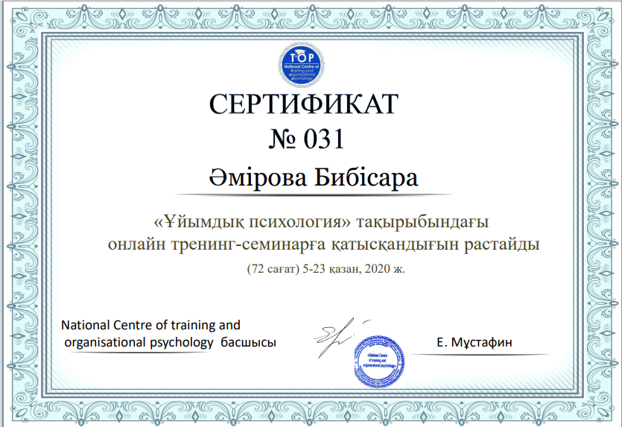

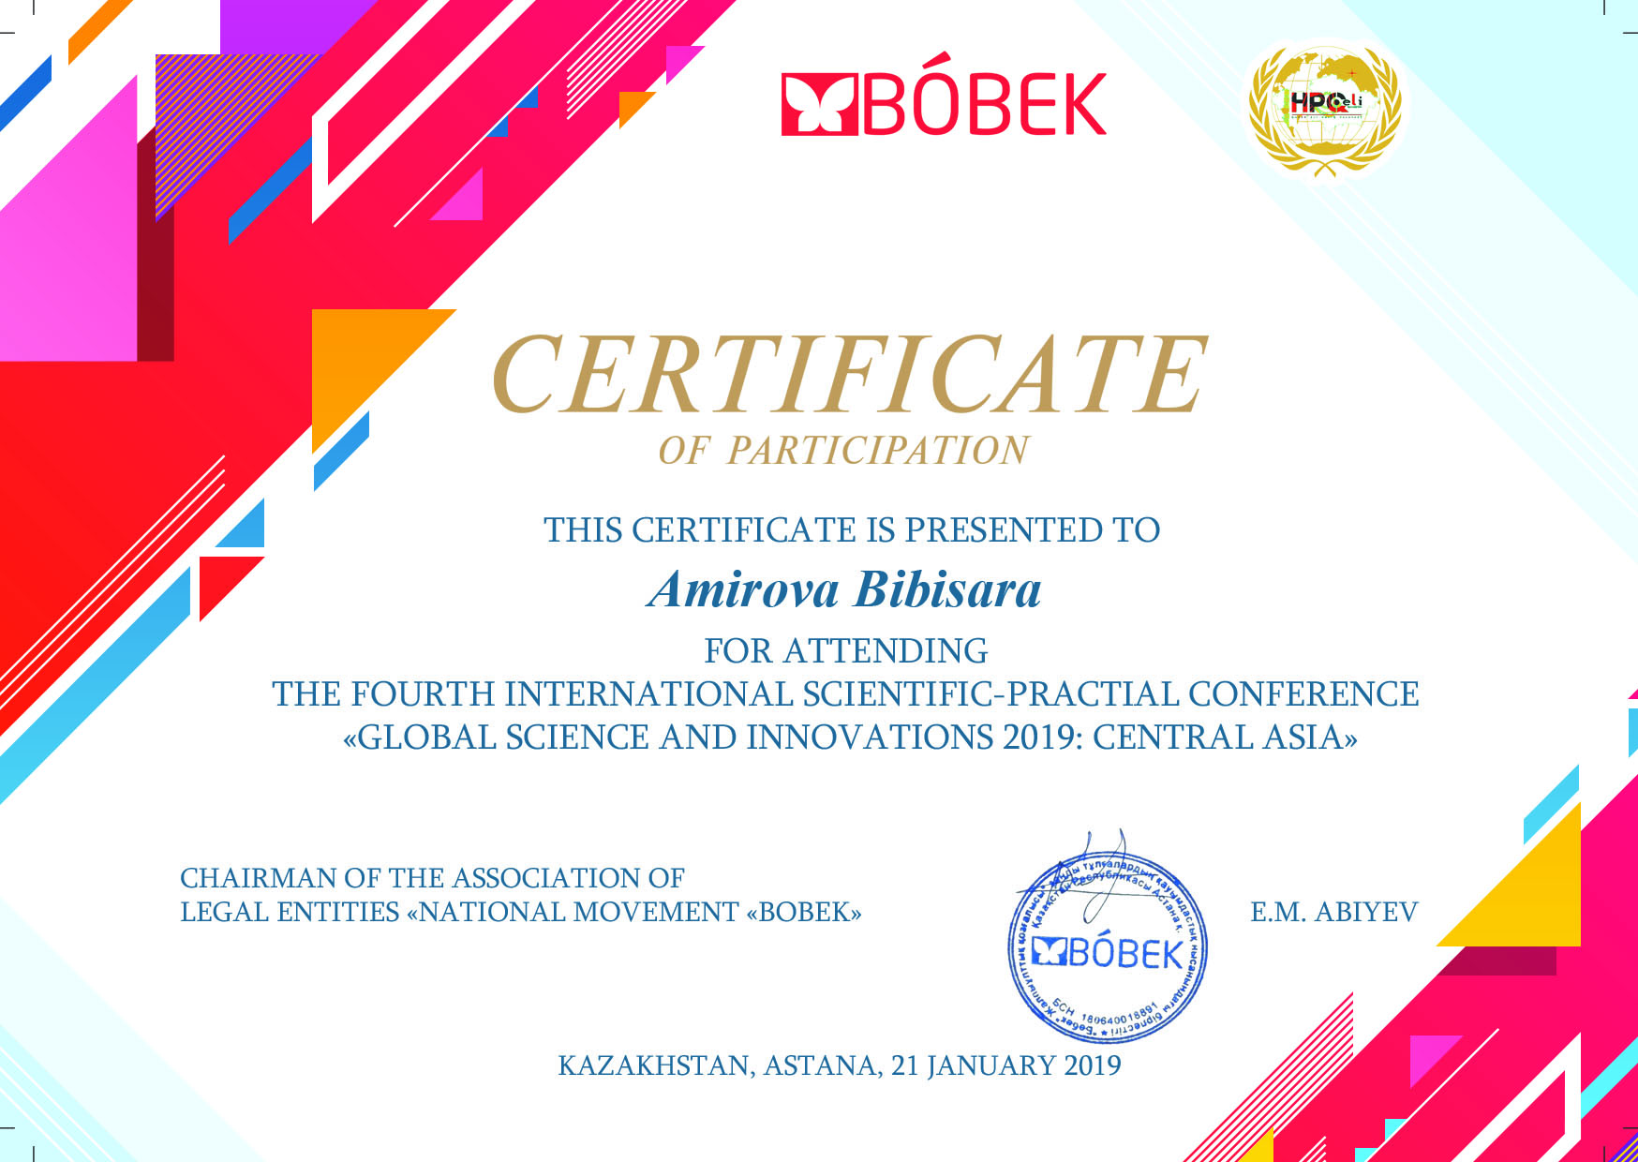
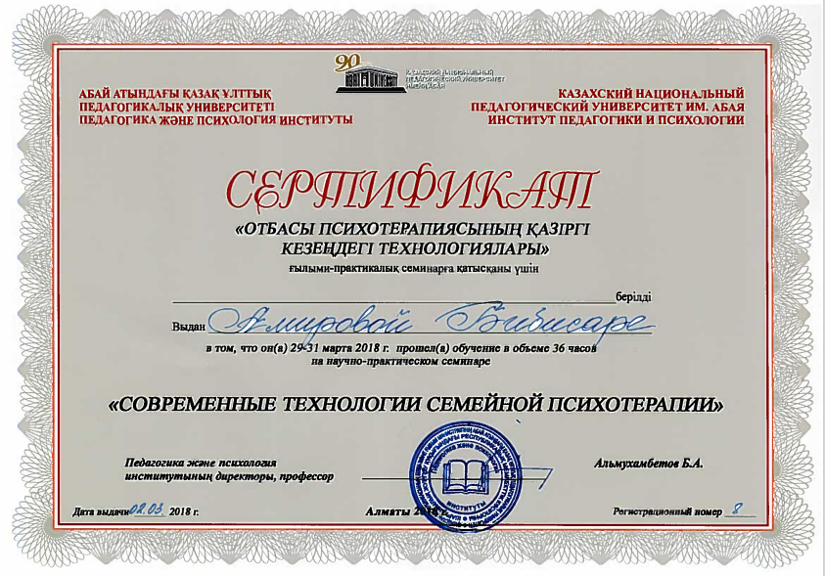
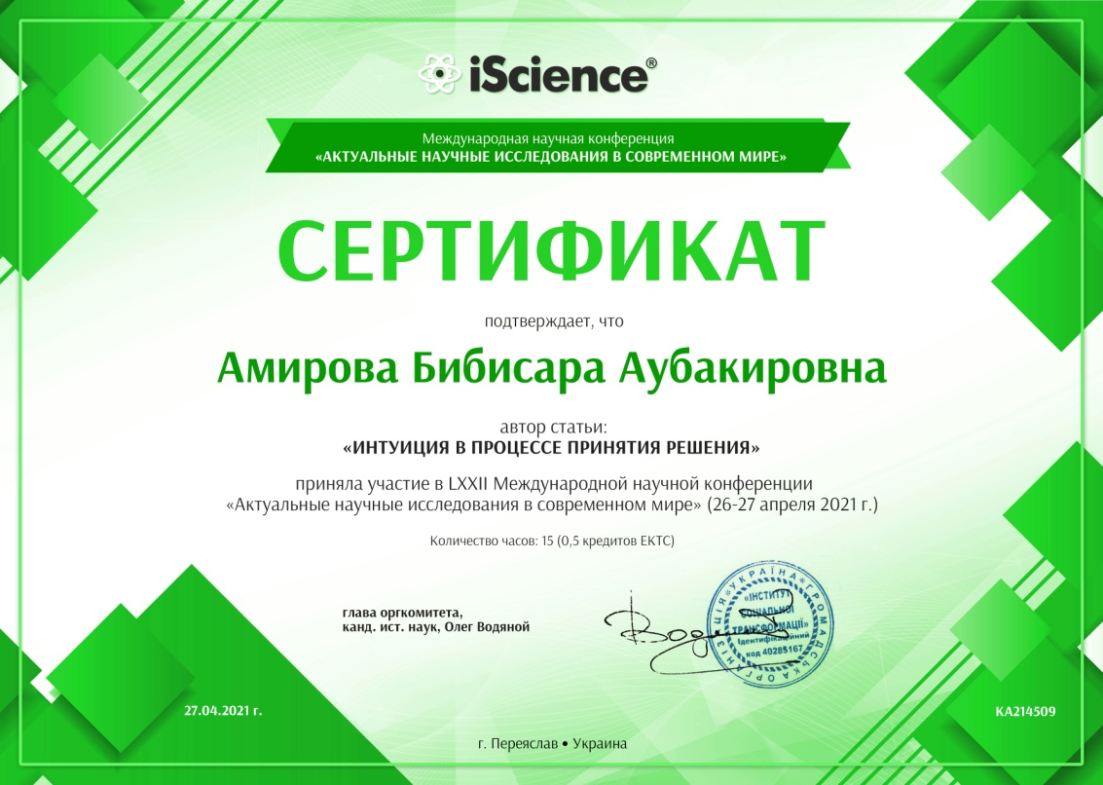

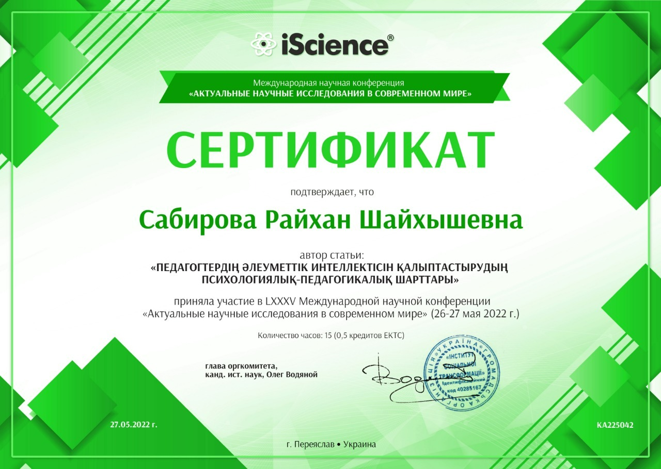

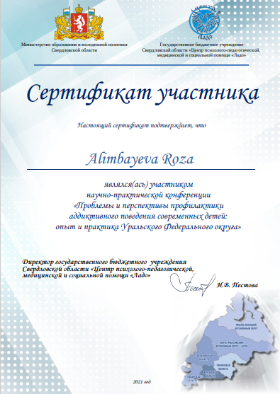
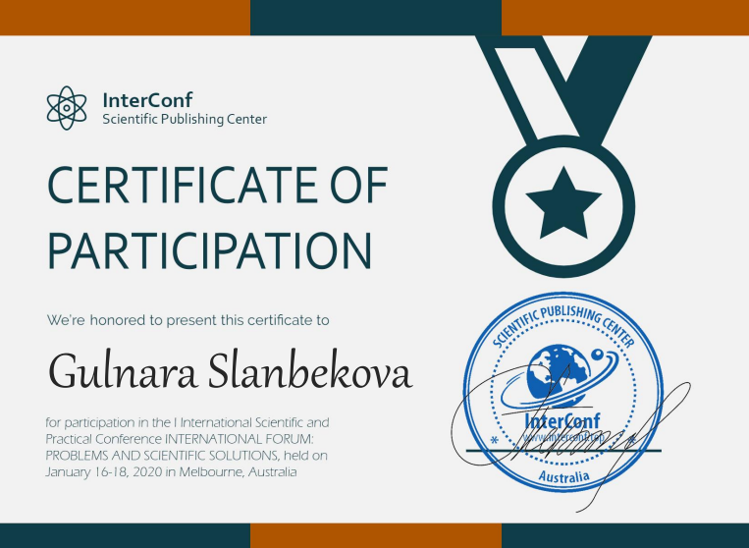
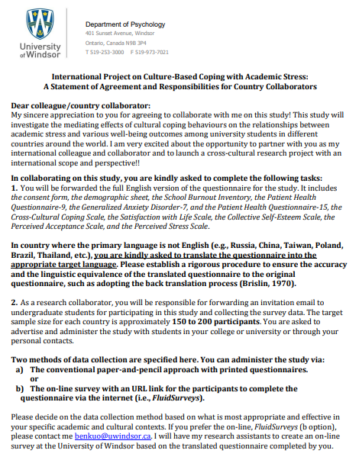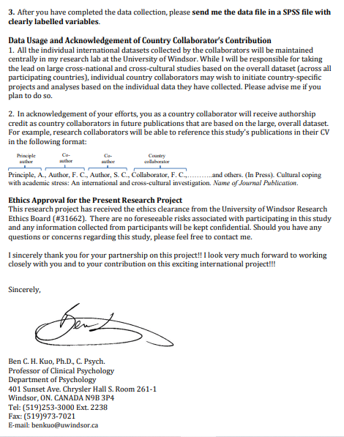

Table 3 Teachers of major subjects (MS) by language proficiency

№ | Total |  | including language proficiency
 |  |  | Kazakh |  | Russian | Kazakh - Russian | Kazakh - English | Russian - English | Kazakh - Russian - English
Total MS teachers including
1 |  | Understands and can use familiar phrases and expressions in speech that are necessary for specific tasks |  |  |  |  | 4 | 4 | 4
2 |  | Understands the main ideas of clear messages delivered in literary language on a variety of topics typically arising from work, study, leisure, etc. |  |  |  |  | 1 | 1 | 1
3 |  | Understands almost any oral or written message, can make a coherent text based on several oral and written sources и письменных источников |  | 6 | 6 | 6 | 1 | 1 | 1

Table 4. Information on professional development (advanced training) of faculty members

№ | 2018 |  |  |  | 2019 |  |  |  | 2020 |  |  |  | 2021 |  |  |  | 2022
 | Total | including professional development organizations |  |  | Total | including professional development organizations |  |  | Total | including professional development organizations |  |  | Total | including professional development organizations |  |  | Total | including professional development organizations
 |  |  |  | Other |  | IAT | HEIs | Other |  | IAT | HEIs | Other |  | IAT | HEIs | Other |  | IAT | HEIs | Other
1 |  |  |  |  | 5 | 1 | 4 |  | 8 |  | 2 | 6 | 22 |  | 2 | 20

Table 5. Publication activity of teaching staff

Staff |  | Portfolio
 | Articles in journals recommended by the Quality Assurance Committee | Articles in journals with non-zero impact factor | Articles in collections  international conferences | Opposition in the defense of doctoral dissertations | Preparation of textbooks (ISBN) | Development of monographs | Development of electronic textbooks | Development of methodological  benefits (ISBN) | Other
Sabirova R.Sh. | 15 | 8 | 5
Amirova B. A. | 4 | 1 | 20 |  | 1 | 2 |  | 1
Alimbaeva R.T. | 9 | 6 |  |  |  | 1 | 1 | 2
Zhanserikova D.A. | 8 | 1 | 3 |  | 1 |  | 4
Kapbasova G.B. | 5 | 2 |  |  |  | 1
Slanbekova G.K. | 19 | 6 |  |  |  | 3 | 1 | 1

Table 6. Partnership with enterprises

№ | The name of the enterprises | Direction of cooperation | Cooperation result s | Further opportunities
1 | Clinic "Panacea", Karaganda | Advanced training of doctoral students | Professional Development Certificate | Expansion of joint research work
2 | IE «Center» | Expert | Participation in the development and approval of the EP | Ensuring continuous expert work on monitoring the EP
3 | LLP "Institute of Psychology and Social Sciences", Astana | Advanced training of doctoral students | Professional Development Certificate | Expansion of joint research work
4 | Department of internal policy of the city of Karaganda | Project | Scientific events within the framework of the project "Organization and holding of a period of activities for the prevention and elimination of religious extremism among youth" | Expansion of joint research work
5 | LLP "Center for Innovative Technologies "Orleu" | Expert, educational | Participation in the jury of competitions, holding webinars, seminars | Expansion of joint research work
6 | Coaching Center LLC, Moscow | Advanced training of doctoral students | Professional Development Certificate | Further expansion of work to improve the qualifications of teaching staff and doctoral students

Table 7. Partnership with schools, organizations of technical and vocational education and

organisations of higher and postgraduate education

№ | The name of the organizations | Direction of cooperation | Cooperation result s | Further opportunities
1 | KSU "Secondary school No. 36" (branch of the Department of Psychology) | career guidance, consulting, training | Informing about the educational programs of the Department of Psychology | Further expansion of the contingent of applicants for the EP of the Department of Psychology
2 | KSU "Gymnasium No. 92" (branch of the Department of Psychology) | research, educational and methodological, organizational and methodological areas | joint scientific and practical conferences, seminars at various levels, exchange of scientific materials | Further expansion of the contingent of applicants for the EP of the Department of Psychology, the implementation of joint research projects
3 | Nazarbayev Intellectual School | project | «READx» project | Further development of joint project activities
4 | PI "Bolashaq Academy" | expert | Participation in the development and approval of the EP | Ensuring continuous expert work on monitoring the EP
5 | Moscow State University named after M.V. Lomonosov | admission of doctoral students for internships | Scientific internship certificate | Further expansion of cooperation, organization of joint research activities
6 | Kazan Federal University | admission of doctoral students for internships | Scientific internship certificate | Further expansion of cooperation, organization of joint research activities
7 | University of Windsor, Ontario, Canada | advisory | Agreement on the joint management of doctoral students | Further expansion of cooperation, organization of joint research activities
8 | "Higher School of Economics", Moscow | advisory | Agreement on the joint management of doctoral students | Further expansion of cooperation, organization of joint research activities
9 | University of Saints Cyril and Methodius, Trnava, Slovakia | advisory | Agreement on the joint management of doctoral students | Further expansion of cooperation, organization of joint research activities
10 | “UrFU named after the first President of Russia B.N. Yeltsin (Russia) | educational and methodical | Reading guest lectures | Further expansion of cooperation, organization of joint research activities

P.1. Evaluation sheets for attended classes

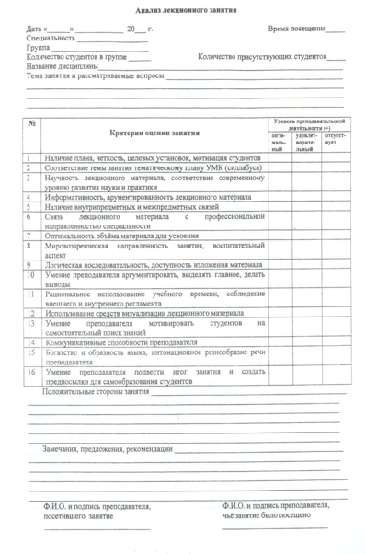

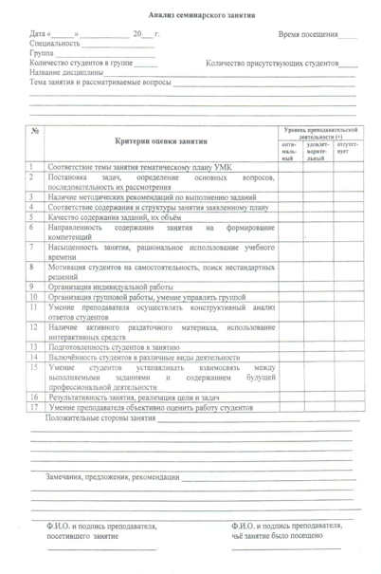

Appendix D3. Material and technical resources of the EP and student support system

Table 1 Availability of information and communication equipment

№ | Name | Number
1 | Number of personal computers, including | 154
1.1 | with Internet access | 154
2 | Number of projectors 3 Number of interactive whiteboards | 15
3 | Number of interactive whiteboards | 15

Table 2 Type of Internet connection

1 | modem connection via a dial-up telephone line | no
2 | ISDN link; | no
3 | digital subscriber line; | no
4 | fiber optic communication | yes

Table.3 Maximum data transmission over the Internet

1 | below 128 kbit/s: | no
2 | 128-255 kbit/s: | no
3 | 256-511 kbit/s: | no
4 | 512 kbit/s – 1,9 Mbit/s: | no
5 | 2 Mbit/s and higher: | yes

Table 4 Availability of special software

№ | Name | Number
1 | Educational computer programs for individual subjects or topics | -
2 | Computer-based testing programs | 2
3 | Electronic versions of reference books, encyclopedias and dictionaries | 3
4 | Electronic versions of textbooks on individual subjects and topics | 8
5 | Electronic library systems | 2
6 | Other software tools | -
7 | Electronic system of interaction between teachers and students (portal) | 2

Table.5 Availability of the website

1 | - email address | office@buketov.edu.kz
2 | - Internet website | www.buketov.kz
3 | - frequency of updating information on the website | as new information becomes available

Table 6 Availability of information on the activities of the organisation of higher and postgraduate education on the website

№ | Name | Presence
1 | Implemented educational programs | Yes
2 | Information about the administration | Yes
3 | Report on educational activities | Yes
4 | Information on employment and adaptation of graduates | Yes
5 | Resume of teachers | Yes
6 | Information about graduates | Yes
7 | Department history | Yes
8 | Applicant's Guide | Yes

Table 7. Purchasing new books

2017/2018. | 2018-2019 | 2019-2020 | 2020-2021 | 2021-2022
20970 ex. | 12 433 ex. | 4 352 ex. | 5186 ex. | 10 557 ex.

Table 8 Access to information technology resources

 | № | Information technology resources | Access |  | Freedom of access
 |  |  | Yes | No | Free | At certain hours
 | Access of engineering and teaching staff to:
 | 1 | computers | Yes |  | Free
 | 2 | the Internet | Yes |  | Free
 | 3 | the of use of necessary software | Yes |  | Free
 | Students' access to:
 | 1 | computers | Yes |  | Free
 | 2 | the Internet | Yes |  | Free
 | 3 | the of use of necessary software | Yes |  | Free
Employee access to:
1 |  | computers | Yes |  | Free
2 |  | the Internet | Yes |  | Free
3 |  | the of use of necessary software | Yes |  | Free

Table9 Library resources

Staff (people)
Area | total (m² ) |  | 4440m²
 | for storing books (m² ) |  | 2893
 | number of seats in the reading room |  | 1078
Book fund | scientific literature | in Kazakh | 81199
 |  | in Russian | 442744
 |  | in English | 6005
 | periodical literature | in Kazakh | 52588
 |  | in Russian | 142598
 |  | in English | 1838
 | textbooks | in Kazakh | 428490
 |  | in Russian | 529673
 |  | in English | 31935
 |  | in Kazakh | 24157

 | electronic editions | in Russian | 34256
 |  | in English | 2831
Activities | average number of readers on a library card per year | students | 8846
 |  | faculty members | 430
 |  | staff | 27
 | per year | students | 464039
 |  | faculty members
 |  | staff
 | average number of visits per year | students | 139374
 |  | faculty members
 |  | staff

Table 10. Student dormitories
Number / name of the dormitory | Total area (m² ) | Year of commissioning | Type of buildi ng | Year when repair was carried out
 |  |  |  | Major | Minor
House of students №4, block A | 3076 m² | 1987 | typical | 2012 | annually

Table 11. Canteens

Total area (m² ) | Year of commissioning | Type of buildi ng | Год Year when repair was carried out
 |  |  | Major | Minor
122,4 m² | 1974 | typical | 2014 | annually

Table 11. Sports and cultural infrastructure

Number / name | Total area (m² ) | Year of commissioning | Type of buildi ng | Year when repair was carried out
 |  |  |  | Major | Minor
Gym | 298 м² | 1974 | typical | 2014 | annually

Table 13. Medical center

Total area (m² ) | Year when repair was carried out |  | Number of seats
 | Major | Minor
31,5 | 2020 | - | 1

Table 14. Receipt of fixed assets to the Faculty of Philosophy and Psychology

№ | Component | 2020 |  | 2021
 |  | Initial cost | Quantity | Initial cost | Quantity
1 | Stamp on automatic equipment | 5500,00 | 1
2 | System block |  |  | 161280,00 | 2
3 | Sand Therapy Kit |  |  | 200000,00 | 1
4 | WiFi router |  |  | 48628,00 | 4
5 | Monitor |  |  | 52080,00 | 2
6 | Television |  |  | 244042,0 | 2

Annex E. Survey results

P.1. Questionnaire "Satisfaction of doctoral students with the quality of the implementation of the educational program" 8D01102 - Educational Psychology"

№ | Characteristics of the quality of the educational program | Doctoral students' opinion  (in points)
1. Conditions of education
1.1 | Material and technical base (the state of the classroom fund, the provision of classes with laboratory equipment, visual materials, etc.) | 5,0
1.2 | Technical equipment (providing the educational process with technical teaching aids) | 5,0
1.3 | The work of student government bodies | 4,8
1.4 | Work of sports clubs (sections) | 4,4
2. The quality of the educational process
2.1 | The level of educational and methodological support for classes | 5,0
2.2 | The quality of the teaching staff | 5,0
2.3 | The level of organization of independent work of doctoral students | 5,0
2.4 | Practice organization level | 5,0
2.5 | The level of organization of research work of doctoral students | 5,0
3. Quality of learning outcomes
3.1 | Level of acquired theoretical knowledge | 5,0
3.2 | The level of acquired skills and abilities | 5,0
3.3 | Compliance with the level of training to modern requirements of the labor market | 5,0
Total: |  | 4,9

P.2. Questionnaire "Satisfaction of doctoral students with the work of domestic and foreign scientific consultants"

№ | Criteria for evaluating the activities of domestic and foreign scientific consultants | Doctoral Students Answers
1 | Opportunity to choose domestic and foreign scientific consultants | «Yes» - 100%
2 | Assistance of a domestic consultant in choosing the topic of a doctoral student’s scientific work | «Satisfied» - 100%
3 | Assistance of a domestic consultant in the development of an individual work plan for a doctoral candidate | «Satisfied» - 100%
4. Evaluation of the professional skills of a domestic research consultant:
4.1 | Demonstrates a deep and systematic understanding of the field of study | 93,9%
4.2 | Demonstrates the ability to propose the development, implementation and adaptation of a coherent research program | 99,1%
4.3 | Contributes to science through research, as reflected in cited national or international publications or patents | 99,9%
4.4 | Has an international reputation in his research field, has contacts in scientific communities, is able to present and interpret research results | 97,9%
4.5 | Makes a positive contribution to the development of scientific knowledge through cooperation and collaboration with other scientists, incl. foreign | 98,4%
4.6 | Publishes papers as a lead researcher, conducts scientific seminars and leads sections at conferences | 100%
4.7 | Defines acceptable research methodology, research methods and approaches | 100%
4.8 | Adheres to the norms of academic integrity and ethics in research and interpersonal communication | 98,6%
5. Satisfaction of doctoral students with the assistance provided by a domestic consultant in:
5.1 | formation of the scientific apparatus of research | 100%
5.2 | substantiation of the theoretical and methodological foundations of the dissertation | 100%
5.3 | publication of articles in journals recommended by the quality control committee | 99,1%
5.4 | publication of articles in journals with a non-zero impact factor included in the Scopus/Web ofScience databases | 100%
5.5 | substantiation of the practical results of the study | 99,1%
5.6 | determining the place and content of a foreign internship | 100%
6 | Satisfaction of doctoral students with consultations of a foreign consultant on the research topic | 98,7%
7 | Satisfaction of doctoral students with the work of a foreign consultant in providing practical advice and recommendations on the plan and content of a doctoral dissertation | 99,3%
8 | Satisfaction of doctoral students with the participation of a foreign consultant in organizing foreign internships in research organizations | 100%
9. The results of the doctoral student with a foreign consultant:
9.1 | got acquainted with global trends in the field of research | 99,4%
9.2 | gained experience of working with foreign scientists | 100%
9.3 | улучшил знания иностранного языка | 97,8%
9.4 | received practical advice when writing and publishing an article in a journal with a non-zero impact factor included in the Scopus / Web of Science databases | 99,1%
10 | Opportunity to listen to lectures of a foreign leader during doctoral studies | 100%

P.3. Questionnaire "Satisfaction with the studied discipline"

№ | Criteria for evaluation | Answers
1 | The discipline is educational and informative. | «Total agree» - 100%
2 | The discipline has practical value and develops the skills necessary for professional activity. | «Total agree» - 98,1%
3 | The discipline has a theoretical novelty and relevance. | «Total agree» - 99,2%
4 | The discipline provides a clear description of the purpose and objectives of the course, its relationship with other disciplines. | «Total agree» - 97,6%
5 | The educational material is connected and logically ordered, new terms are presented clearly and structured. | «Total agree» - 99,3%
6 | The training material is supported by visual diagrams, explaining examples. | «Total agree» - 99,1%
7 | Tasks for independent work of doctoral students are clearly formulated, support for its implementation is provided | «Total agree» - 100%
8 | In general, I am satisfied with the content and structure of the discipline | «Total agree» - 100%

P.4. Questionnaire "Satisfaction of employers with the quality of graduate training"

№ | Criteria for evaluation | Answers
1 | How would you rate your degree of participation in the university's graduate employment program? | «Very high» - 100%
2 | How would you rate the quality of EP graduates' training? | «Very high» - 100%
3 | How would you rate the level of development of professionally important qualities of EP graduates? | «Very high» - 100%
4 | How would you rate the level of theoretical training of graduates in the EP? | «Very high» - 100%
5 | Which of the following methods does your organization use to recruit professionals? | Direct dialing from an educational institution

Appendix F. EP Development Plan